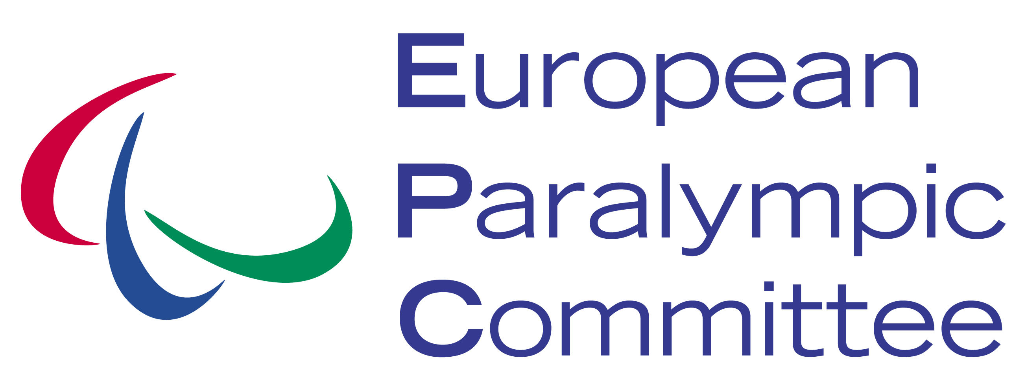

|  |  |
| --- | --- |
| https://scontent-a-fra.xx.fbcdn.net/hphotos-xpa1/v/t1.0-9/522128_434126676619514_234829412_n.jpg?oh=b33c00c20142c74d076bdd2756c1ea1d&oe=5479E5AC | https://scontent-a-fra.xx.fbcdn.net/hphotos-xaf1/v/t1.0-9/487475_465013906864124_471038889_n.jpg?oh=9c1314f4d679e1d8e6ea90df092bd023&oe=546BCE16 |
| **EPC YOUTH AMBASSADOR APPLICATION PACK** | |
| https://scontent-b-fra.xx.fbcdn.net/hphotos-xap1/v/t1.0-9/553105_434142476617934_1482799674_n.jpg?oh=a2cbf63f14b85631e9e2a8e02bf6bbca&oe=54739A8D | https://fbcdn-sphotos-f-a.akamaihd.net/hphotos-ak-frc3/v/t1.0-9/8075_434126936619488_29554096_n.jpg?oh=fc90cd0ed2af3f968bc2e2d7c96e52ca&oe=54696DB8&__gda__=1415910806_b602a49909f42fec3700cc05e9304a4f |
| ***BECOME AN EPC YOUTH AMBASSADOR AND YOU WILL:***   * ***Participate in a week long leadership and development training week at the EPC Headquarters in Vienna, Austria*** * ***Become an Ambassador for the Paralympic Movement in Europe*** * ***Promote and raise awareness about ParaSport to young people throughout Europe, with the backing of the European Paralympic Committee and National Paralympic Committee*** * ***Have the potential to travel to EPC sporting events as an EPC Youth Ambassador*** | |

|  |
| --- |
| **YAMBA: EPC YOUTH AMBASSADORS** |
|  |
| **APPLICATION PACK** |

***The YAMBA Project***

The EPC Youth Ambassadors Project (YAMBA) is an exciting 12 month programme managed and delivered by the European Paralympic Committee which will give the opportunity for 8 young people aged 18-25 from throughout the region to train towards becoming ParaSport Ambassadors.

Funded by the Agitos Foundation Grant Support Programme 2014, the project will run until July 2015 and will involve 8 individuals, with two representatives from each of the sub-regions of the EPC. The participants will take part in a week long training and development programme at the EPC headquarters in Vienna, Austria, and become a fully-fledged EPC Youth Ambassador.

***What is an EPC Youth Ambassador?***

An EPC Youth Ambassador promotes Paralympic Sport to the young people of Europe, seeking to raise awareness not only of the Paralympic Movement but also of the opportunities which exist for young people with a disability to take part. Furthermore, an EPC Youth Ambassador will play a key role in representing the voice of young ParaAthletes in Europe, receiving training and mentorship to become the leaders of tomorrow.

***What is the profile of an EPC Youth Ambassador?***

In order to apply to become an EPC Youth Ambassador there are some basic requirements which need to be met first. Applicants should:

* Be passionate about ParaSports
* Aged between 18 – 25
* Have a good level of English
* Have experience of ParaSport either as an athlete, coach, official or support staff
* Be effective communicators
* Be able to work as part of a team and individually
* Be available during 25-29 March 2015
* Be available to attend the EPC Youth Games (to be confirmed) during August 2015

***How do I become an EPC Youth Ambassador?***

Once you’ve checked the EPC Youth Ambassador profile, you should proceed to the application form and answer the questions provided. Once you have completed your application form you should return it electronically to [yamba@europaralympic.org](mailto:yamba@europaralympic.org)

***Important Information***

* Being an EPC Youth Ambassador is unpaid
* The EPC will cover travel costs, accommodation and catering costs of the EPC Youth Ambassador during the Seminar week in Vienna. Bookings will be managed by the EPC.
* The EPC is an equal right organisation and does not discriminate based on gender, race, religion, sexuality or disability.

For further information of the YAMBA project and the EPC Youth Ambassadors please go to europaralympic.org or contact [yamba@europaralympic.org](mailto:yamba@europaralympic.org)

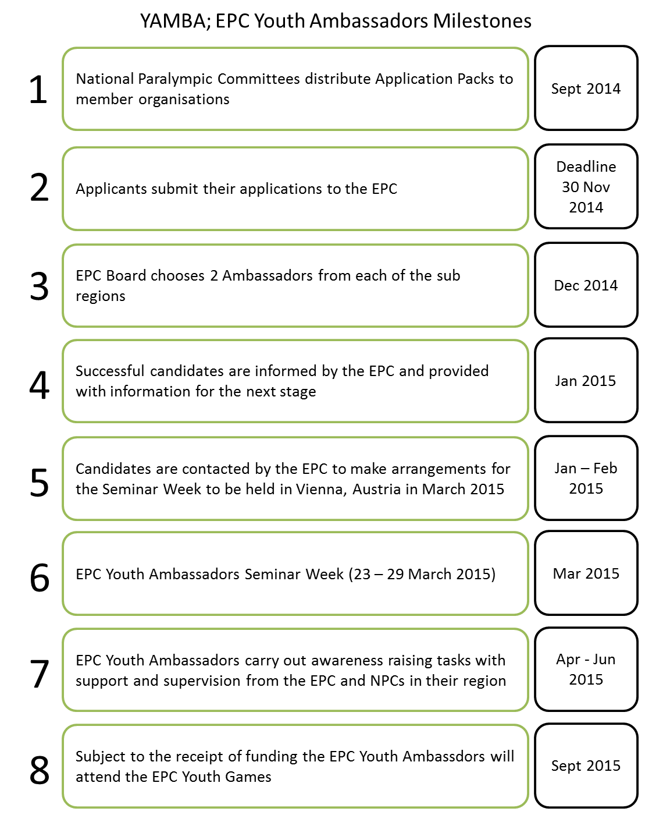

**EPC YOUTH AMBASSADORS APPLICATION FORM**

|  |  |  |
| --- | --- | --- |
| *Application form should be completed in English* | | |
| First Name | Click here to enter text. | Photo (please insert below – if available) |
| Surname | Click here to enter text. |  |
| Gender | Choose an item. |
| Date of Birth (DD/MM/YYYY) | Click here to enter text. |
| Nationality | Click here to enter text. |
| Telephone Number  (incl. country code) | Click here to enter text. |
| Email Address | Click here to enter text. | |
| Contact Address | Click here to enter text. | |

|  |
| --- |
| 1. Please state your highest level of education or training with a brief description of your area of study (Max 100 words): |
| Click here to enter text. |

|  |  |  |  |
| --- | --- | --- | --- |
| 1. In the box below, please provide your level in English and any other language from A1-C2 based on the Common European Framework Reference for Languages [Self-Assessment Grid in this link](http://www.langcen.cam.ac.uk/culp/CEF_sa_grid.pdf). | | | |
| *Language* | *Understanding* | *Speaking* | *Writing* |
| English | Choose an item. | Choose an item. | Choose an item. |
| Click here to enter text. | Choose an item. | Choose an item. | Choose an item. |
| Click here to enter text. | Choose an item. | Choose an item. | Choose an item. |
| Click here to enter text. | Choose an item. | Choose an item. | Choose an item. |

|  |
| --- |
| 1. Please describe your previous experience in ParaSport, with particular reference to any leadership roles which you might have held (Max 200 words): |
| Click here to enter text. |

|  |
| --- |
| 1. Please describe the skills you have which would make you an excellent EPC Youth Ambassador (Max 200 words): |
| Click here to enter text. |

|  |
| --- |
| 1. Please describe your strongest characteristic or quality and how it would be beneficial when serving as an EPC Youth Ambassador (Max 200 words): |
| Click here to enter text. |

|  |
| --- |
| 1. Please explain why you would like to become an EPC Youth Ambassador (Max 200 words): |
| Click here to enter text. |

|  |
| --- |
| 1. Finally, describe what your expectations of the YAMBA; EPC Youth Ambassadors project are? What impact do you think the project can have on awareness of ParaSport in Europe and the development of Youth ParaSport? (Max 200 Words) |
| Click here to enter text. |

|  |
| --- |
| Please state any specific arrangements which will you will require with relation to travel, accommodation or participation during the Seminar Week: |
| Click here to enter text. |

|  |  |
| --- | --- |
| Please list a referee, someone who can confirm all of the information provided above and give a positive character reference for you. This person should be someone in a position of responsibility who has worked with you previously or in a position of educational leadership (e.g. Coach, Lecturer, Teacher, Employer etc): | |
| Name | Click here to enter text. |
| Role/Position | Click here to enter text. |
| Email address | Click here to enter text. |
| Telephone Number | Click here to enter text. |
| Note: The referee you have provided above will only be contacted in specific circumstances and will not be contacted without your prior knowledge. | |

Please send the filled form to: [yamba@europaralympic.org](mailto:yamba@europaralympic.org)